

* Project Name : Deploying a podcast website using Azure Services
* Group Members : Vinayak Shinde
* Date : 24/10/2023

Introduction :

Deploying a podcast website using Azure Services is a great way to share your audio content with a global audience. Azure, Microsoft's cloud computing platform, offers a wide range of tools and services that can help you host, manage, and scale your podcast website efficiently and securely. In this guide, we will explore the process of deploying a podcast website on Azure, covering key steps and services involved.

To get started, you'll need to create or develop your podcast website. This website will serve as the platform for hosting your episodes, show notes, and engaging with your audience. You can build your website using popular web development technologies, such as HTML, CSS, and JavaScript, or choose a content management system (CMS) like WordPress for a more straightforward setup.

Azure Web Apps is a Platform as a Service (PaaS) offering that allows you to host and run web applications in the cloud. You can deploy your podcast website on an Azure Web App, which simplifies the process of managing your web server and infrastructure. It supports various programming languages and frameworks, making it compatible with most web development technologies.

Azure Storage is Microsoft's cloud storage solution for modern data storage scenarios. Azure Storage offers a massively scalable object store for data objects. It provides a file system service for the cloud, a messaging store for reliable messaging, and a NoSQL store.

Azure Storage is a service that you can use to store files, messages, tables, and other types of information. You use Azure Storage for applications like file shares. Developers use Azure Storage for working data. Working data includes websites, mobile apps, and desktop applications. Azure Storage is also used by IaaS virtual machines, and PaaS cloud services.

Application Insights is an extension of Azure Monitor and provides Application Performance Monitoring (also known as “APM”) features. APM tools are useful to monitor applications from development, through test, and into production in the following ways:

* Proactively understand how an application is performing.
* Reactively review application execution data to determine the cause of an incident.

In addition to collecting metrics and application telemetry data, which describe application activities and health, Application Insights can also be used to collect and store application trace logging data.

The log trace is associated with other telemetry to give a detailed view of the activity. Adding trace logging to existing apps only requires providing a destination for the logs; the logging framework rarely needs to be changed.

**Objectives :**

The goals of Deploying a podcast website using Azure Services project are to:

* Efficient Content Delivery: Ensure that podcast episodes are delivered efficiently and reliably to a global audience, minimizing latency and buffering issues.
* Scalability: Design the website infrastructure to handle a growing number of podcast listeners and ensure that it can scale as the audience expands.
* Reliability: Minimize downtime and ensure high availability to guarantee that podcast content is accessible to users 24/7.
* Cost Optimization: Optimize infrastructure costs by using Azure's pay-as-you-go pricing model and efficiently managing resources to avoid unnecessary expenses.
* User Engagement: Provide feature user-friendly interfaces to enhance the audience's interaction with the podcast.
* User Experience: Focus on creating a seamless and enjoyable experience for your audience, making it easy for them to discover, access, and engage with your podcast content.

**Benefits :**

The Deploying a podcast website using Azure Services project provides the following benefits:

* Scalability: Azure provides scalable infrastructure, allowing your podcast website to handle increasing traffic and demand without downtime. You can easily accommodate a growing audience and handle traffic spikes, especially when releasing new episodes or during marketing campaigns.
* Global Reach: Azure's global network of data centers ensures that your podcast content can be delivered quickly and reliably to listeners around the world. This minimizes latency and buffering issues, improving the user experience for international audiences.
* Cost Efficiency: Azure's pay-as-you-go pricing model allows you to control costs more effectively. You only pay for the resources you use, and you can scale up or down as needed, making it cost-effective for both small and large podcasting operations.
* High Availability: Azure ensures high availability with redundancy and failover options, minimizing downtime. This means your podcast website remains accessible to listeners 24/7.
* Analytics and Insights: Azure provides powerful analytics tools that allow you to track website performance and user behavior. This data helps you make data-driven decisions, refine your content strategy, and understand your audience better.
* Content Management: Azure Blob Storage simplifies the management and storage of podcast episodes and related media files. This makes it easy to organize and serve your content efficiently to users.

**Azure services :**

1. Web App :

Azure Web Apps is a Platform as a Service (PaaS) offering that allows you to host and run web applications in the cloud. You can deploy your podcast website on an Azure Web App, which simplifies the process of managing your web server and infrastructure. It supports various programming languages and frameworks, making it compatible with most web development technologies.

1. Storage Account :

Azure Storage is Microsoft's cloud storage solution for modern data storage scenarios. Azure Storage offers a massively scalable object store for data objects. It provides a file system service for the cloud, a messaging store for reliable messaging, and a NoSQL store.

Azure Storage is a service that you can use to store files, messages, tables, and other types of information. You use Azure Storage for applications like file shares. Developers use Azure Storage for working data. Working data includes websites, mobile apps, and desktop applications. Azure Storage is also used by IaaS virtual machines, and PaaS cloud services.

1. Container :

Azure Blob Storage is a service that stores unstructured data in the cloud as objects or blobs. Blob stands for Binary Large Object. Blob Storage is also referred to as object storage or container storage.

Blob Storage can store any type of text or binary data. Some examples are text documents, images, video files, and application installers.

Blob Storage uses three resources to store and manage your data:

* An Azure storage account
* Containers in an Azure storage account
* Blobs in a container

1. Application Insights :

Application Insights is an extension of Azure Monitor and provides Application Performance Monitoring (also known as “APM”) features. APM tools are useful to monitor applications from development, through test, and into production in the following ways:

* Proactively understand how an application is performing.
* Reactively review application execution data to determine the cause of an incident.

In addition to collecting metrics and application telemetry data, which describe application activities and health, Application Insights can also be used to collect and store application trace logging data.

The log trace is associated with other telemetry to give a detailed view of the activity. Adding trace logging to existing apps only requires providing a destination for the logs; the logging framework rarely needs to be changed.

**Project Architecture :**

1. Azure Web App:

* Host your podcast website on an Azure Web App. It provides an environment for running web applications and supports various programming languages and frameworks.
* Utilize multiple instances to ensure high availability and load balancing to handle traffic spikes.

1. Azure Blob Storage:

* Store your podcast media files, such as audio episodes and images, in Azure Blob Storage.
* Implement Azure Content Delivery Network (CDN) to cache and distribute content globally for efficient delivery.

1. Azure Media Services:

* Use Azure Media Services for encoding and streaming of podcast episodes. It can transcode media files into various formats for different devices and bitrates.
* Implement dynamic packaging to serve content based on the user's device and network conditions.

1. Podcast Content Management:

* Implement a content management system (CMS) or use a headless CMS to manage podcast episodes and related content.
* Integrate CMS with your website for easy content updates.

1. Global Content Delivery:

Use Azure CDN to cache and distribute media content globally, reducing latency and improving download speeds for users.

1. Backup and Disaster Recovery:

Implement regular backups and disaster recovery strategies to safeguard your podcast content and website data.

**Conclusion :**

Deploying a podcast website using Azure Services offers podcast creators numerous advantages that can significantly enhance their podcasting experience. Azure's robust cloud infrastructure provides scalability, security, and high availability, ensuring that your podcast content is efficiently delivered to a global audience. With the ability to automate routine tasks, gain valuable insights through analytics, and customize your website to match your branding, Azure empowers podcasters to focus on creating compelling content while streamlining the technical aspects of website management. Moreover, Azure's cost-effective pay-as-you-go pricing model and support for compliance and regulatory requirements make it an ideal choice for podcast hosting. By harnessing the power of Azure, podcasters can expand their reach, engage with their audience, and build a successful and sustainable podcasting platform.

**Step by Step Process of making project :**

Step 1:-

go to the azure portal and login from your user credentials as shown below in the screenshot

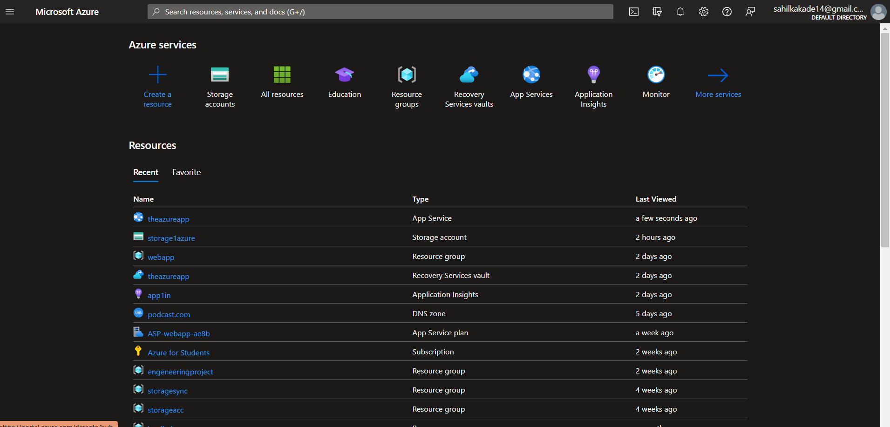

Now click on create a resource

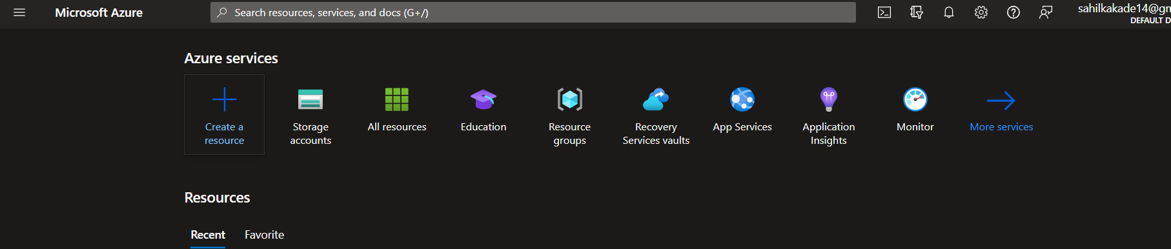

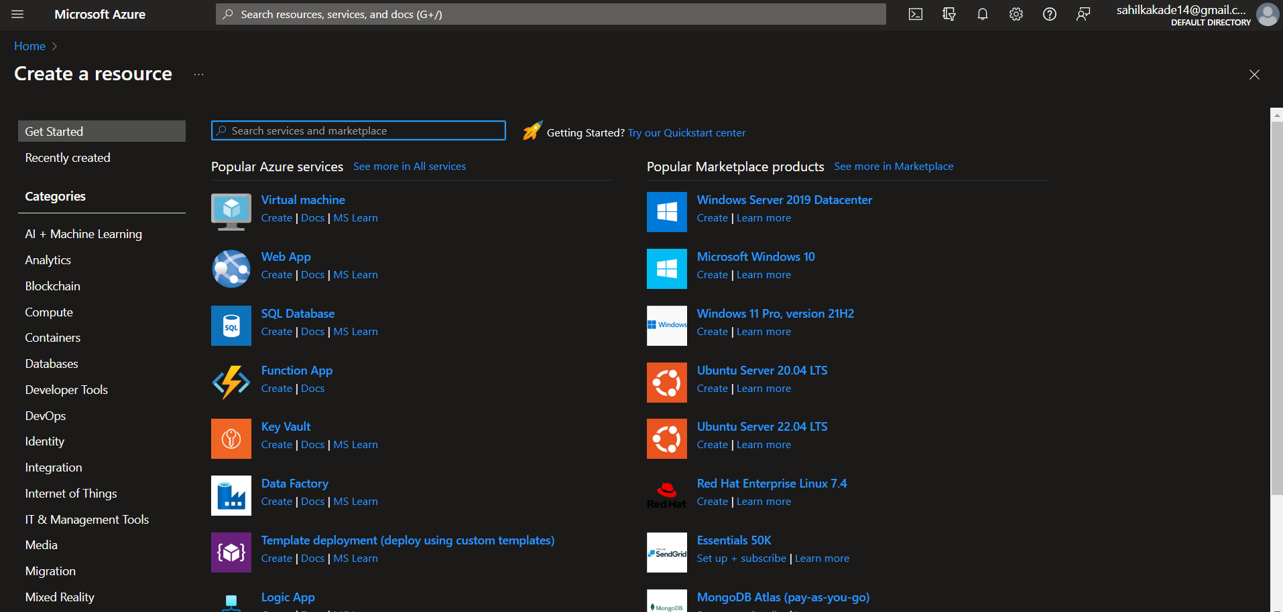

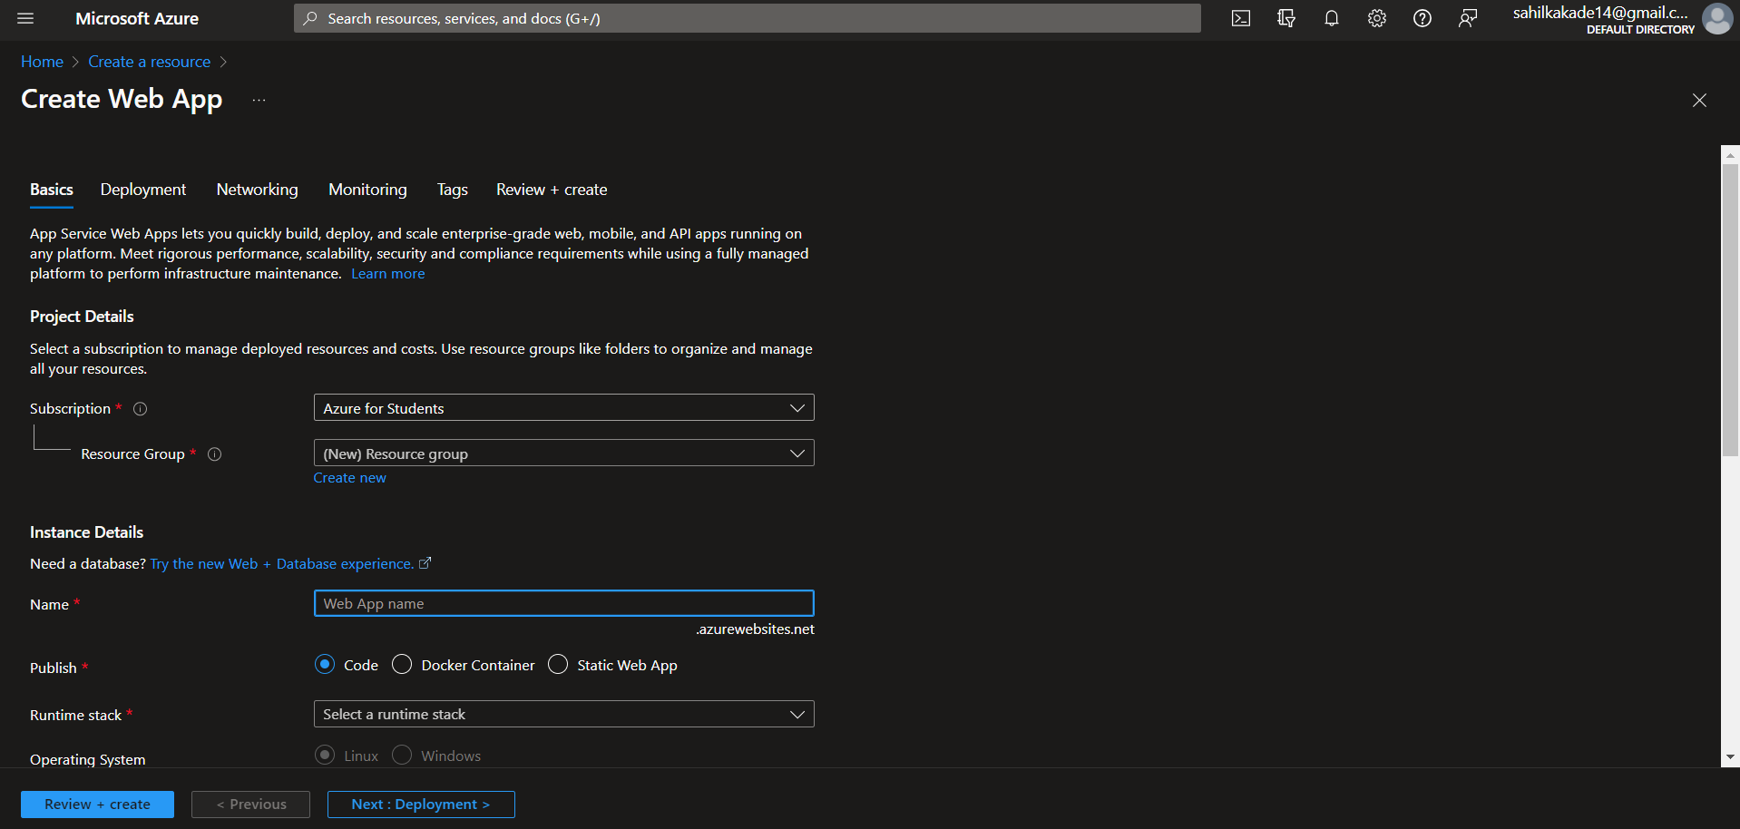

Now Click On the Web App Service as shown in the image it’s one of the most important service that we are using

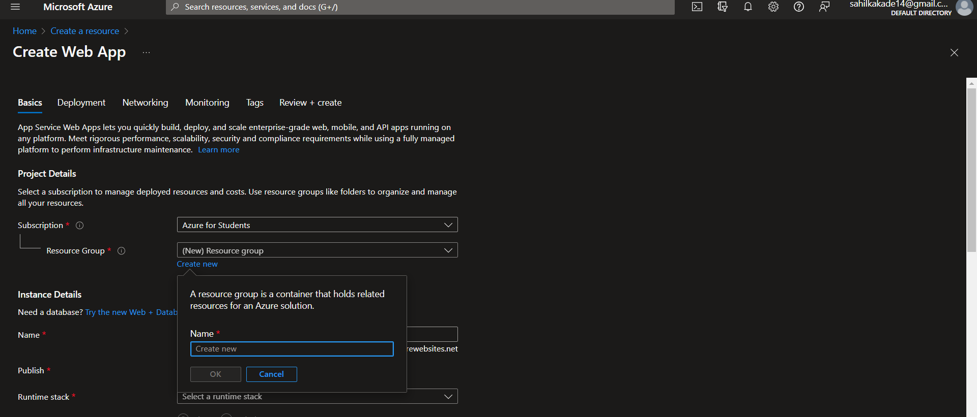

Now Create a new resource group in the resource group section

And click OK

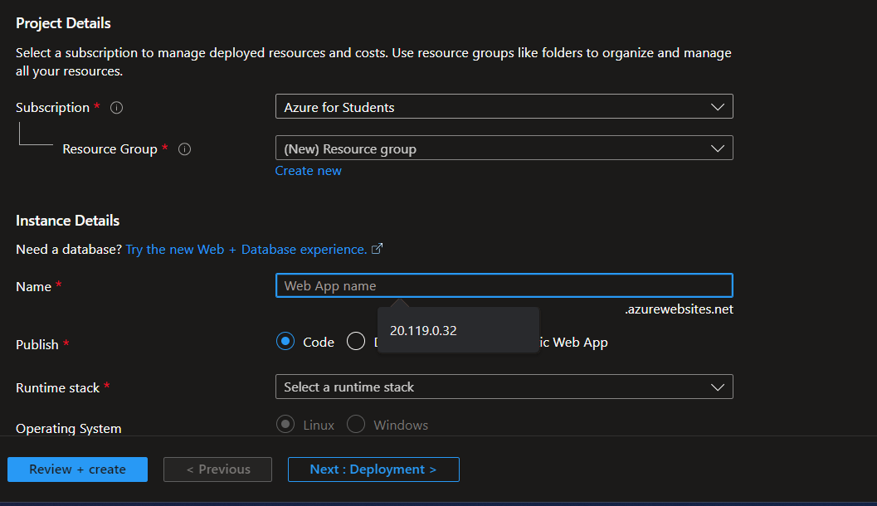

Now Give the web app name as per you want in our case we gived the web app name as per our requirement which is the Azure webapp

Select the Region where you want your web app to be located we chose East us

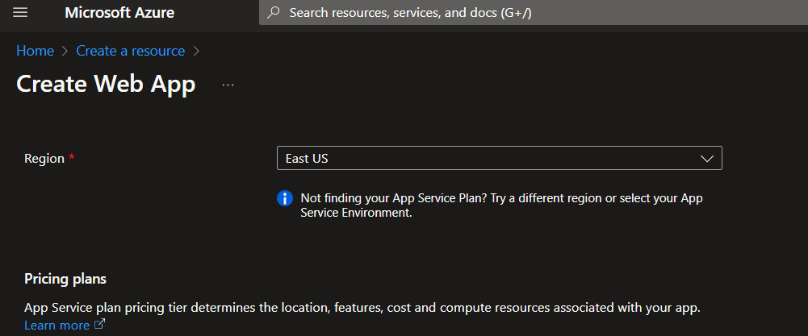

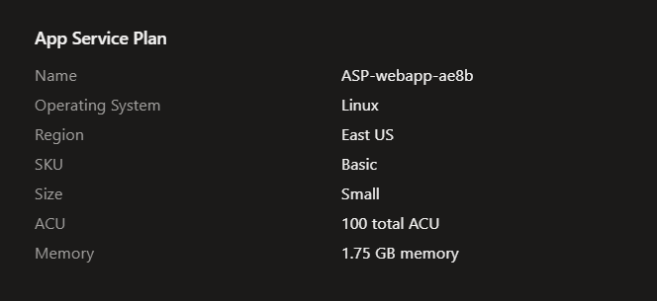

Now Review + Create it.

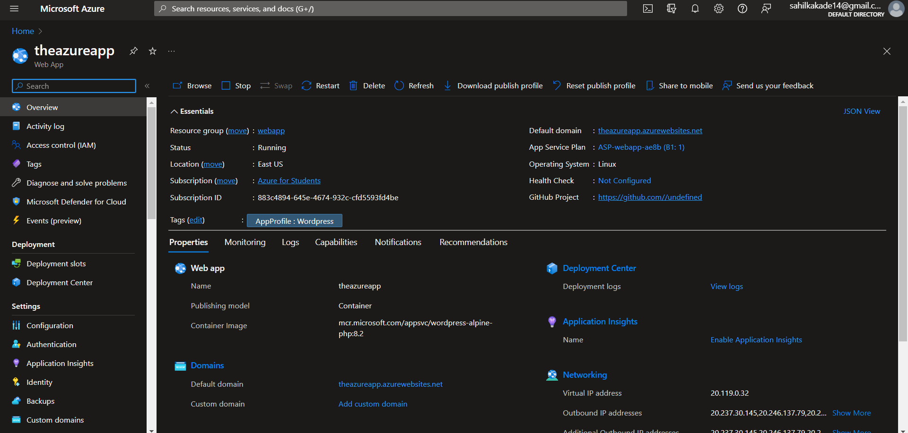

As you can see the web app has been created.

Step 2:- Now we are going to create a website in it which is in the wordpress.

To do that we have to enter the default domain which is given to us by the azure



Just copy that default domain and paste it in your browser

In our case our domain is shown In the above image,

And afte that domain just add /wp-admin.



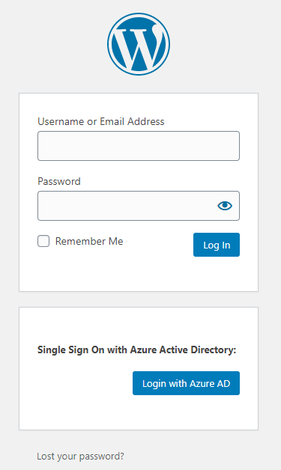

After that you should be directed to the log in page where you should put the log in credentials which you have given while creating the azure app ; be careful if the azure credentials are wrong you will not be able log in and you will have to create new app again.

Step 3:-

Now you will be directed to the wordpress dashboard after installing it it takes some time to install wordpress for the first time.

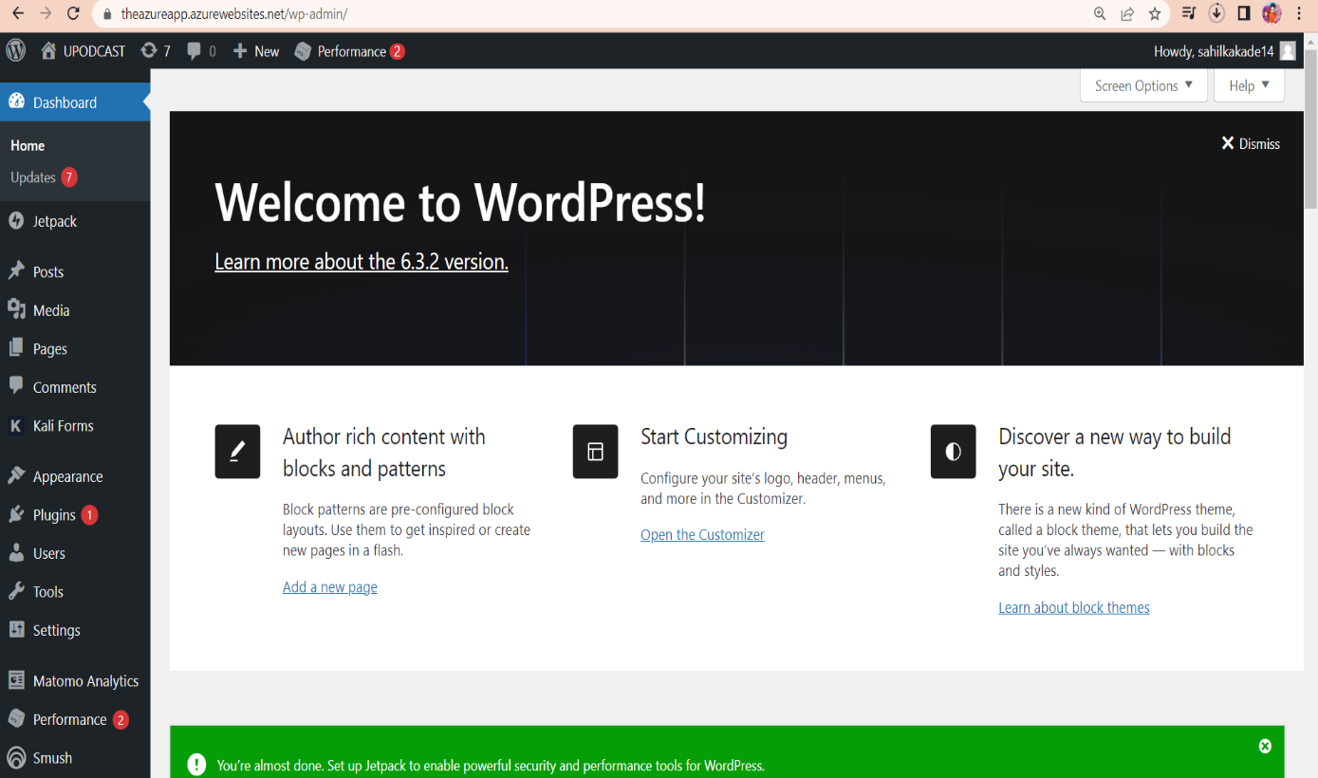

So as we know wordpress is all about building a website faster we can just use some templates customize them accordingly and add our content in it and we are good to go.

But for that first of all we are going to nedd some templates or themes,

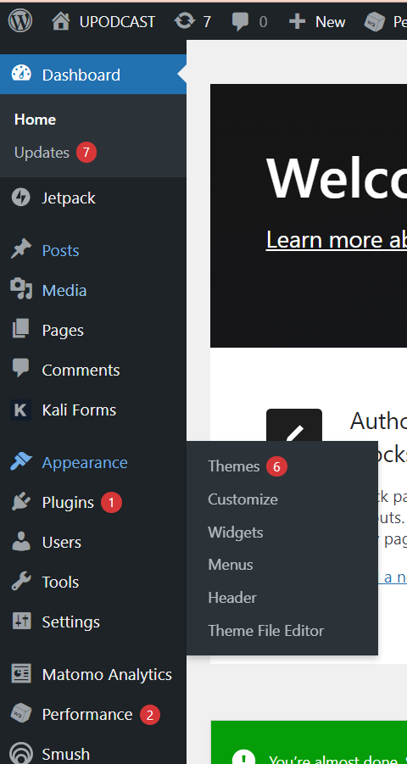

Go to the appearance tab of the dashboard and click on themes,

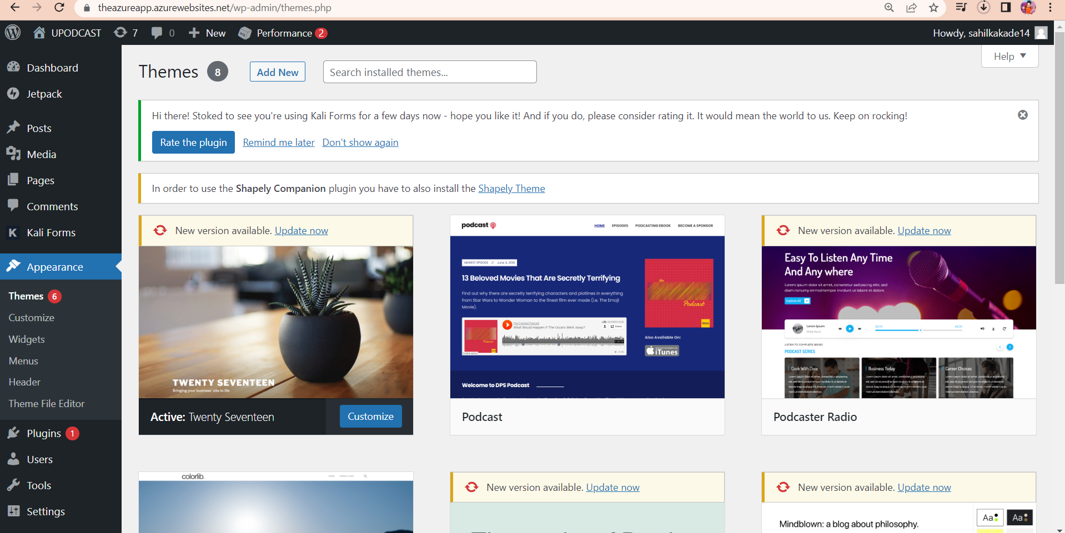

Here we are able to see the themes which are available, or we can add our third-party themes for the WordPress too.

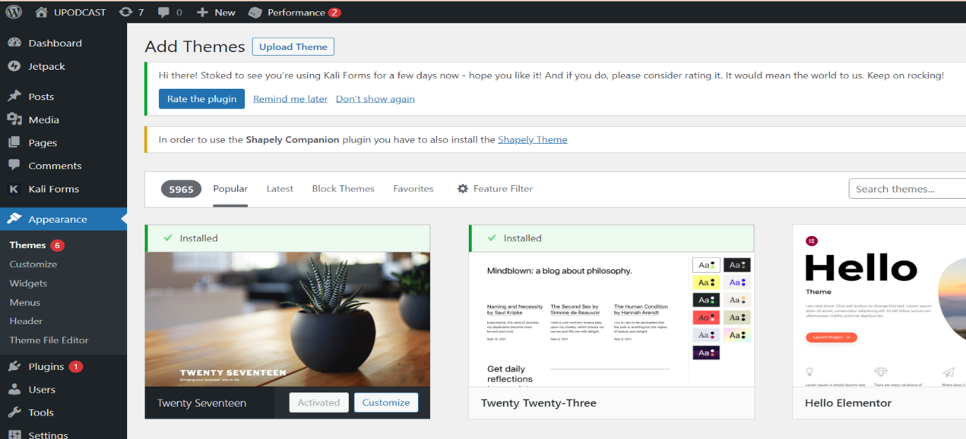

Click on add new and we are able to add the themes in it.

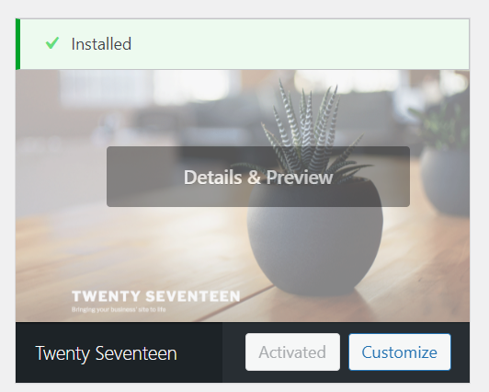

After adding that theme install it and activate it otherwise, we can't use that particular theme.

Now click on customize after adding that theme.

Step 3:- now to before customizing the themes we have to add the plugins in the wordpress it will help us to build a nice website.

We can find the plugins in the dashboard section of the wordpress page

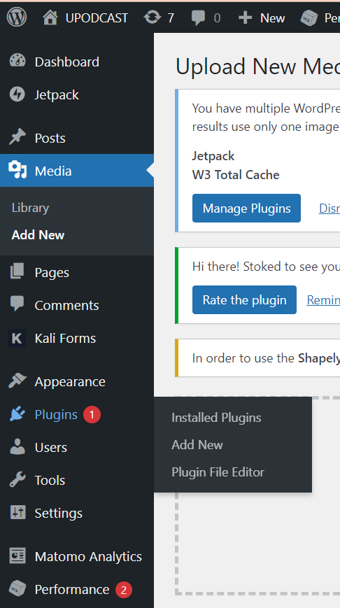

Install all the necessary plugins for that particular them to work properly as shown in the demo of that theme.

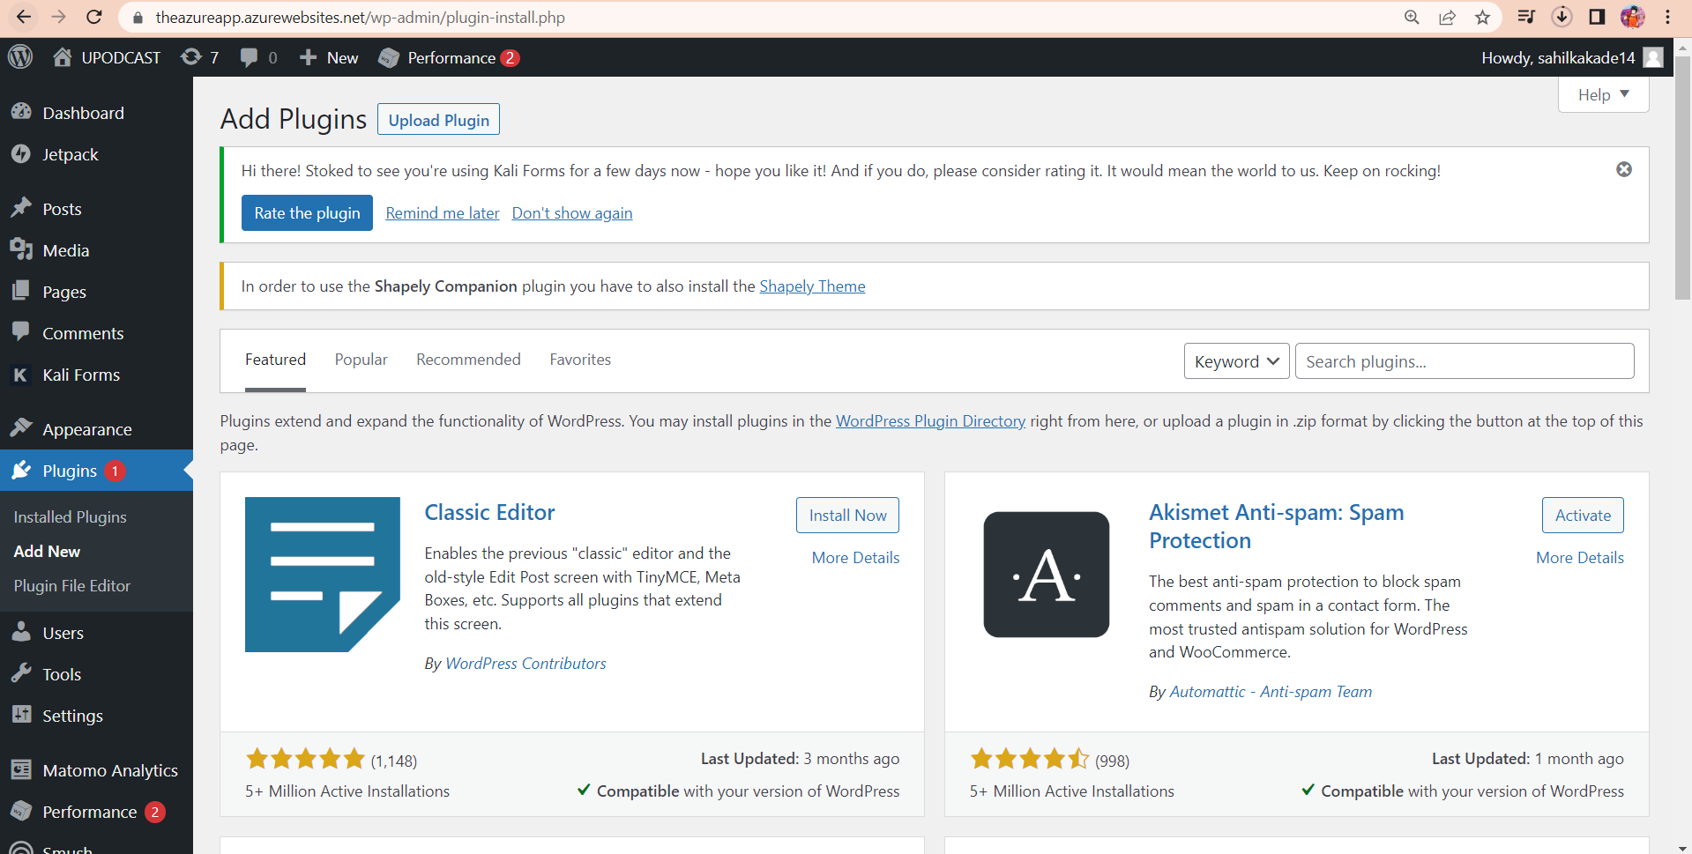

Check if the plugins are installed properly go to the installed plugins section.

And check if the plugins properly installed,

Before editing the theme and creating website update WordPress to the latest version available and also update the plugins cause there are very frequent updates to the plugins.

Step 4: -

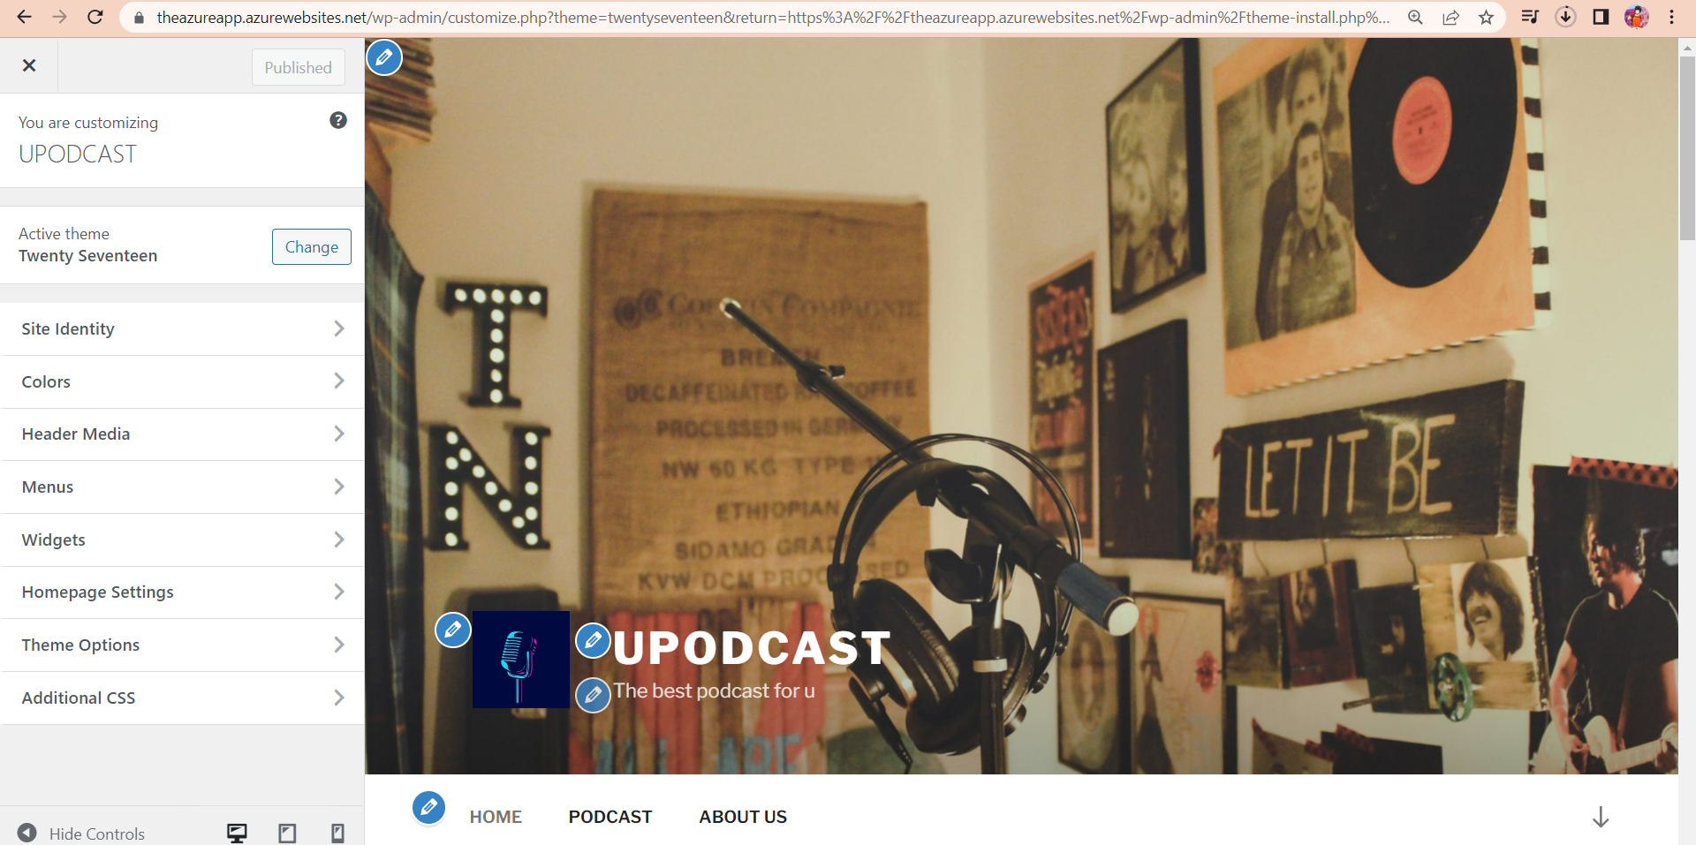

Click on to the customize theme so the above page will get open, where we can make all the changes regarding to our requirements of the website.

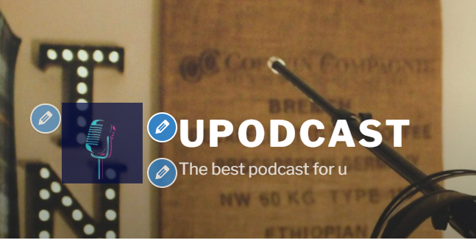

The blue edit pencil buttons showcases the edit option for that particular image or the text.

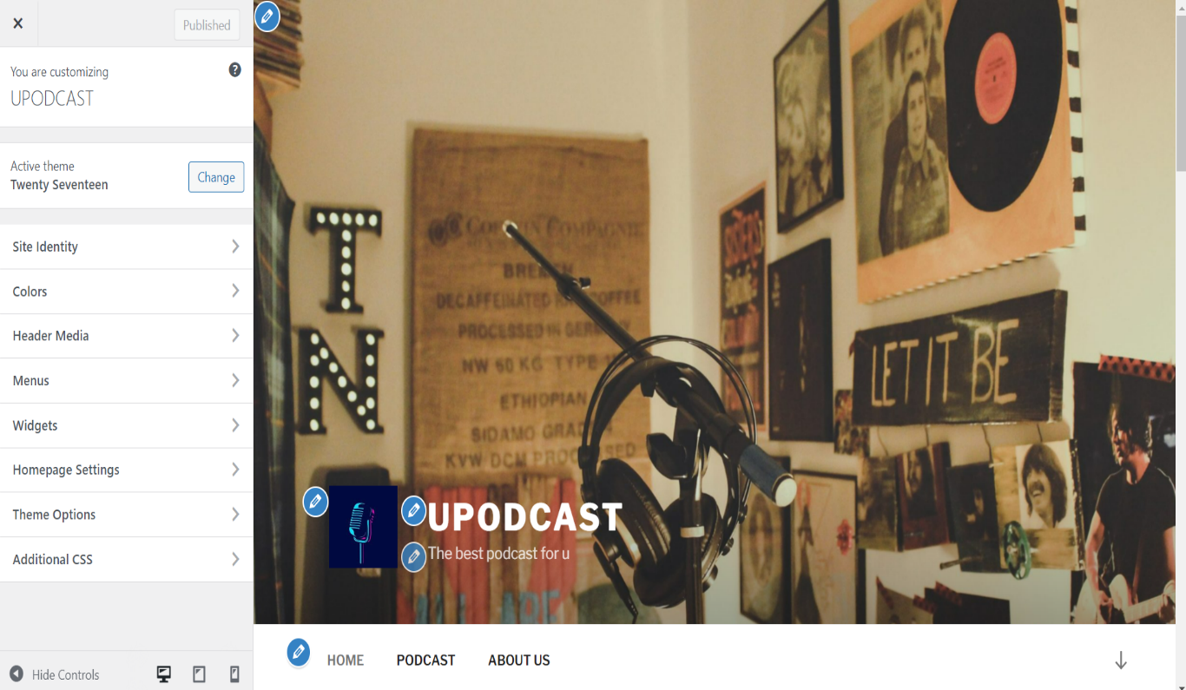

We have also added the background image and logo to our requirements ,

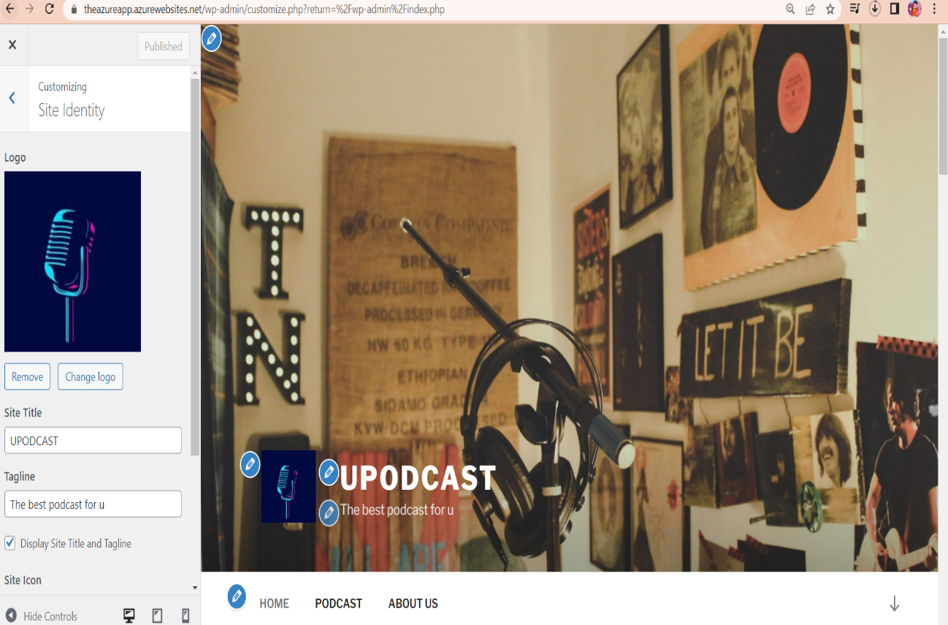

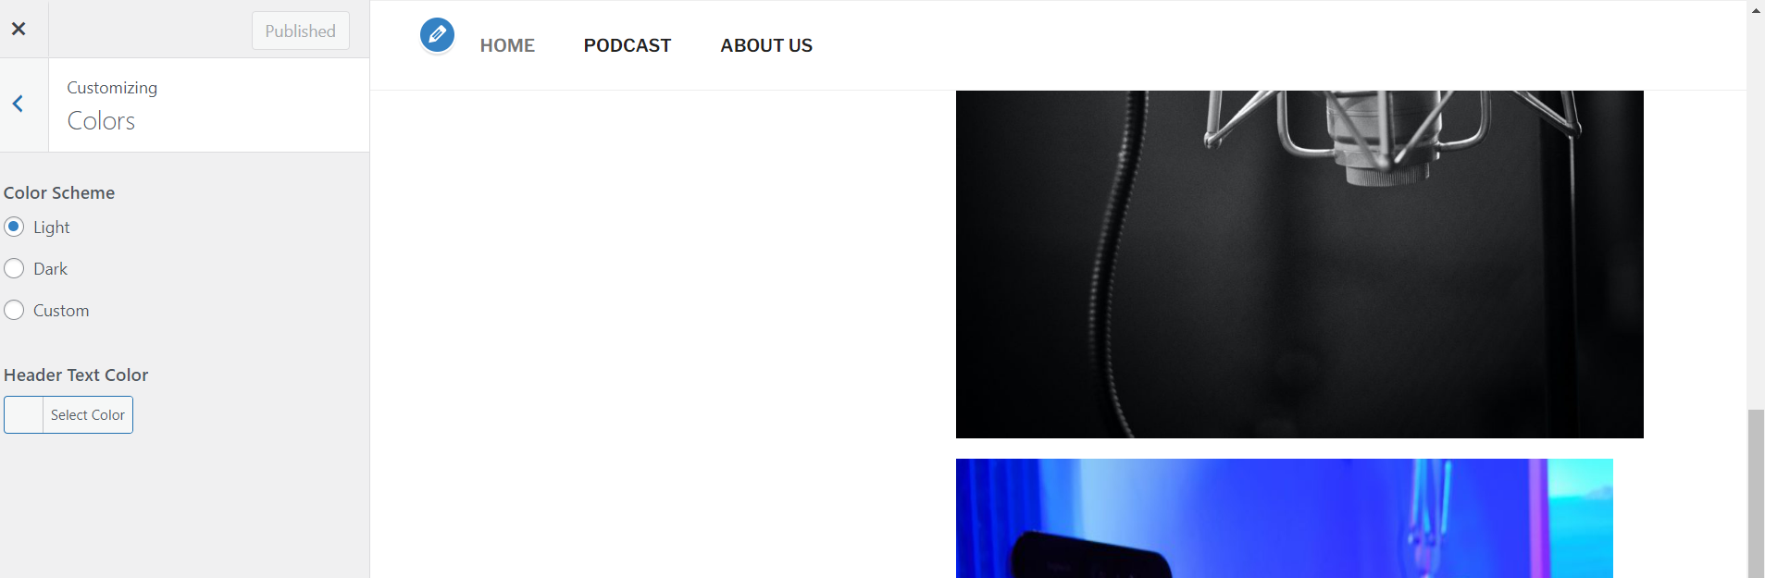

And we changed the background media of the website by image shown below,



We can add more menus by going to the menus tabs

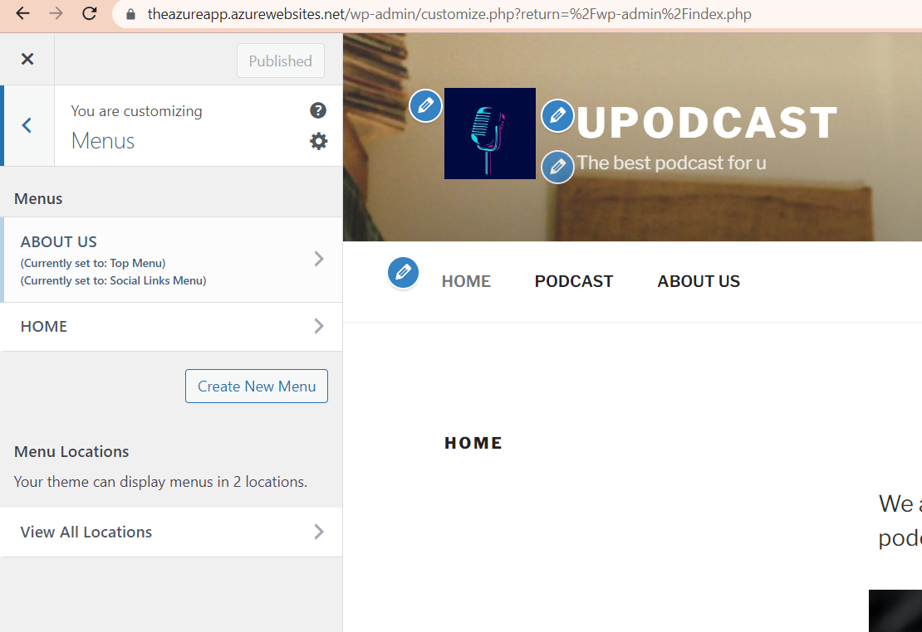

Such as home, about us, and podcast.

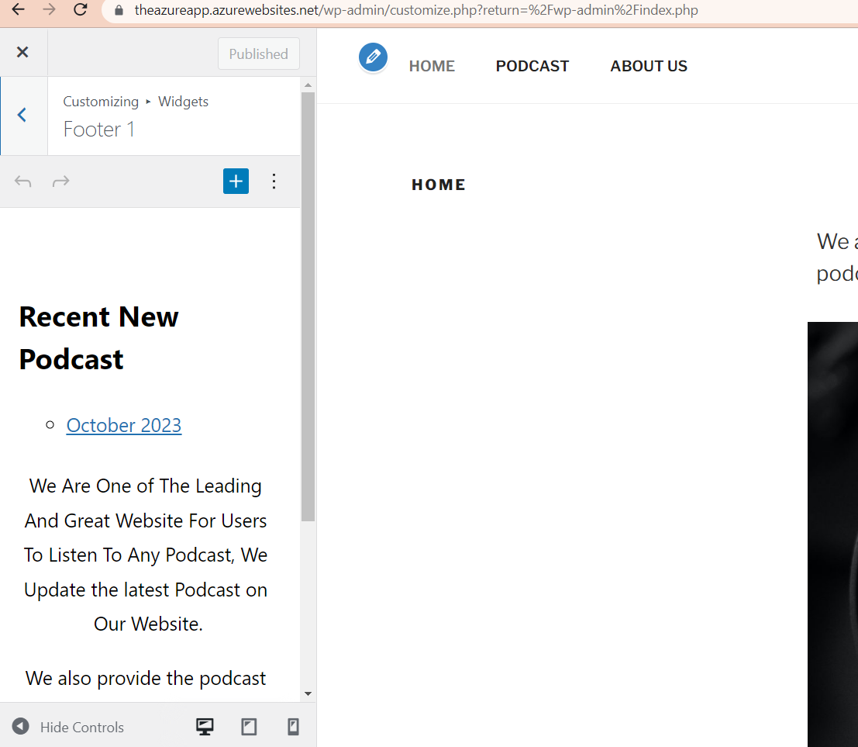

We can also add the footer in the website in our case the footer is “Recent New Podcast” . And the latest podcast widget.

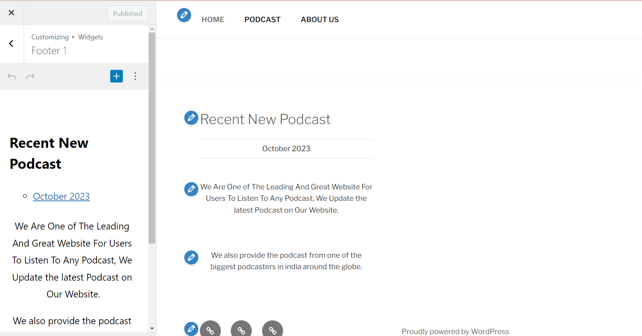

And we can add additional css also in the website according to our user requirements.

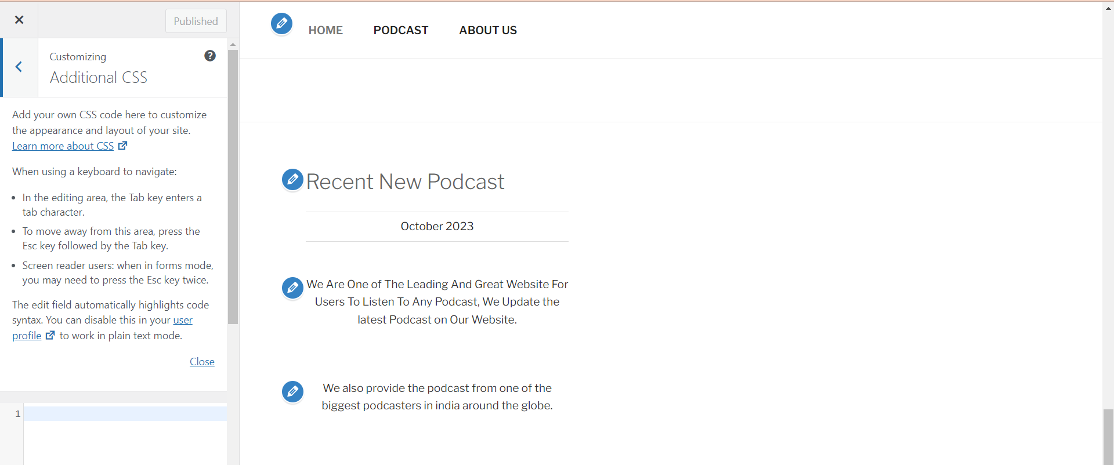

Now after creating the pages we are able see them in the dashboard pages section

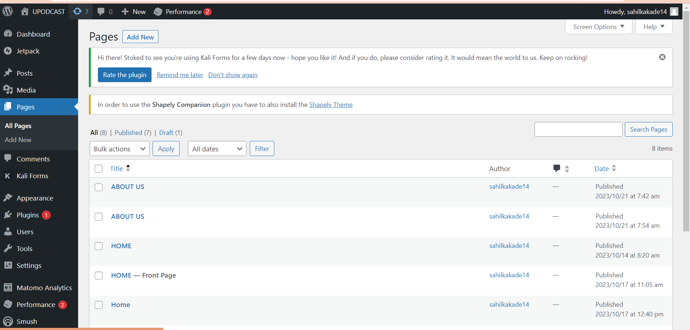

Step 5: -

And before customizing further more we have also added two more other service from azure from the AZ-104

1) App Service

2) Storage Account

3) Application Insights

Step 6: -

Storage account:-

1. We have created a storage account in azure for our website so all the media which is being uploaded by the administrator to customize the website will be automatically also updated or stored in the storage account too for backup purposes.
2. For that the steps are as follows:

I) go to the azure portal and search in the search bar as storage account and click on it

II)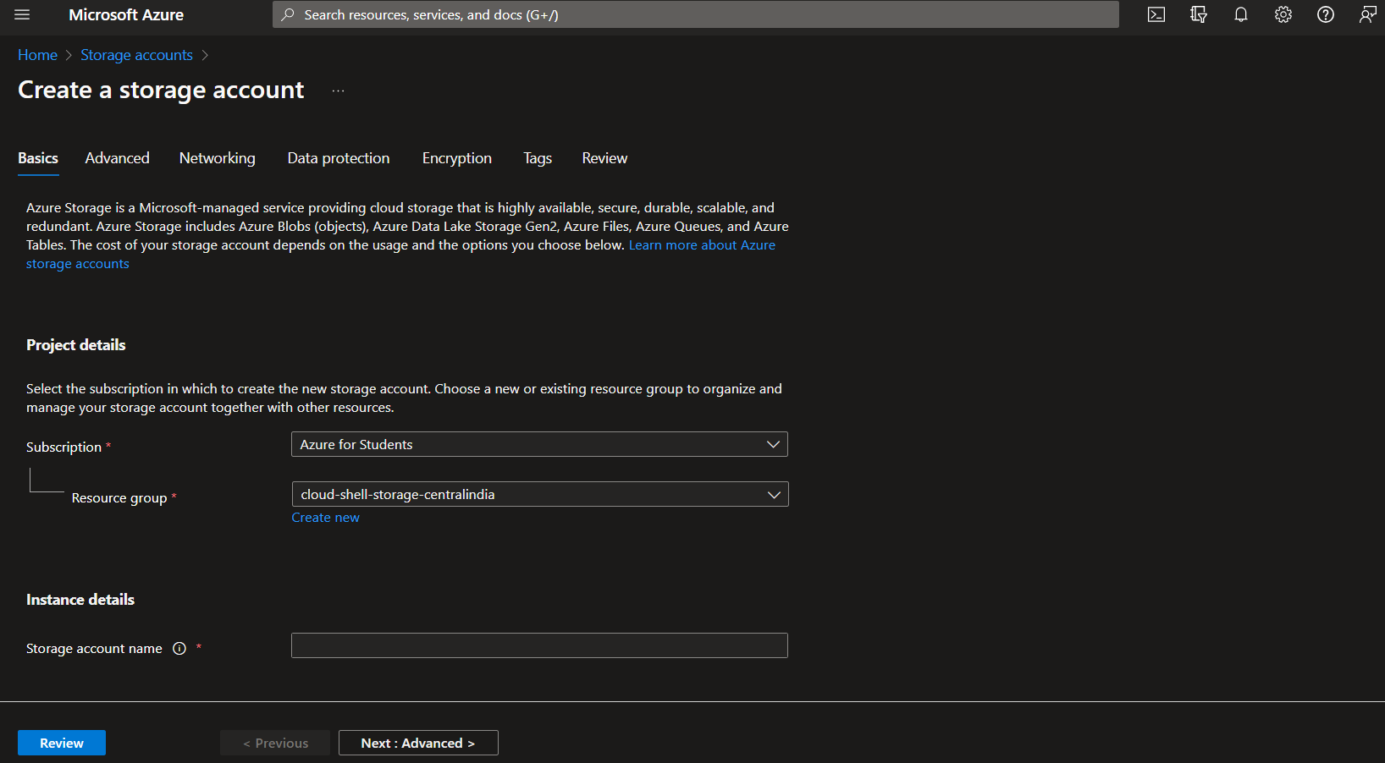

fill up the credentials as per your requirement we have added this storage account to our resource group in which the web app service is being hosted its very importahnt to have the both in the same resource group otherwise I will not work.

III) 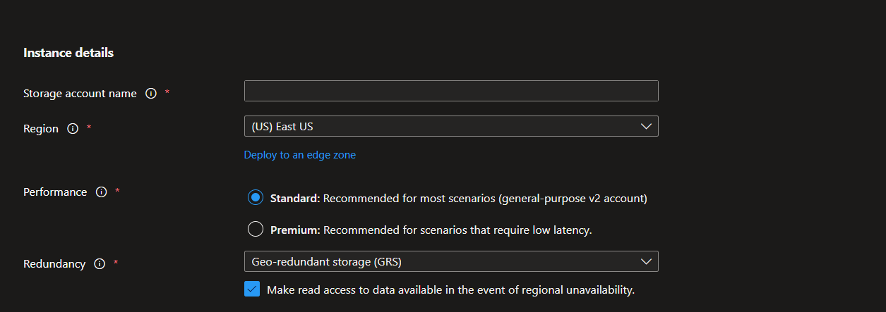

and review and create.

III) 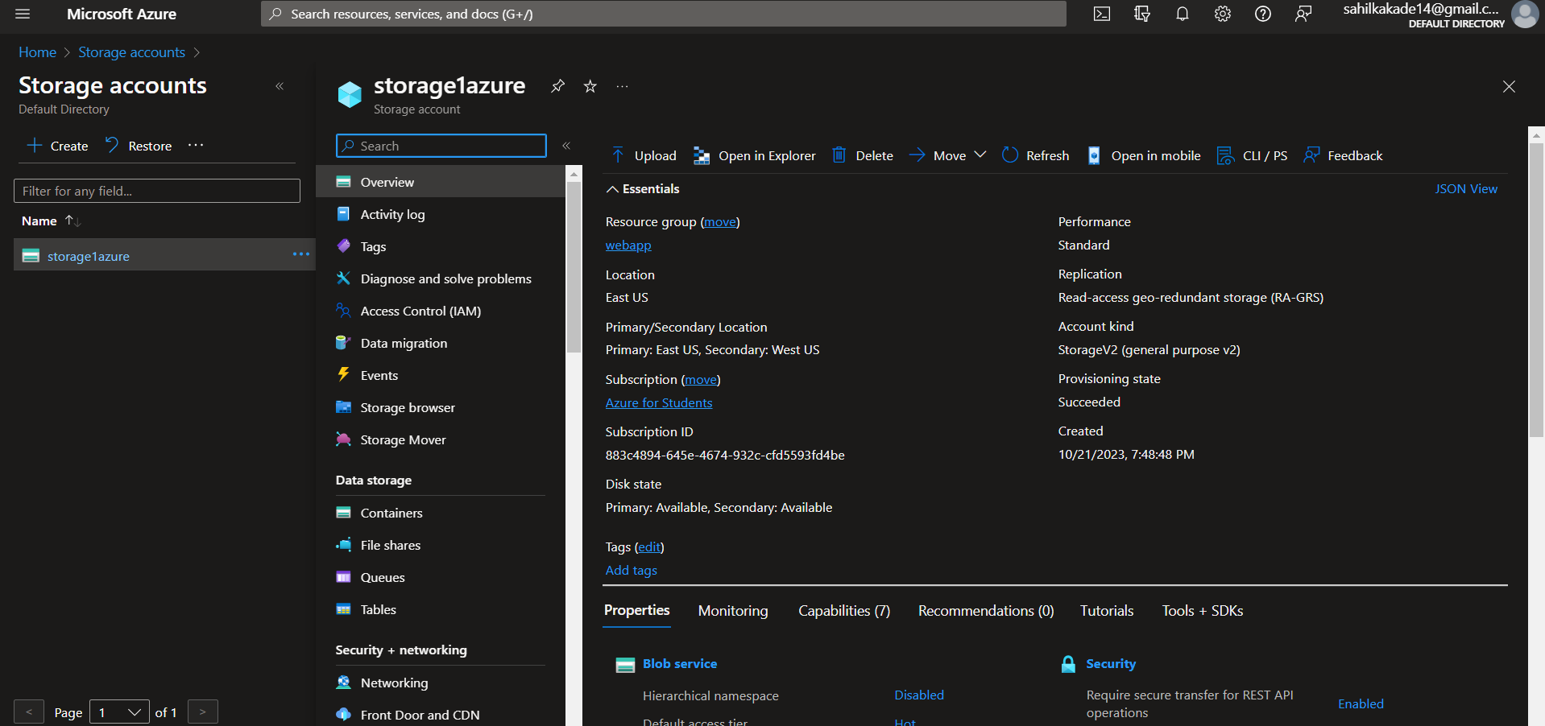

IV) Now we Have created a container and in that container we have created a blob where we can store the media files which are being uploaded on the website.

V) 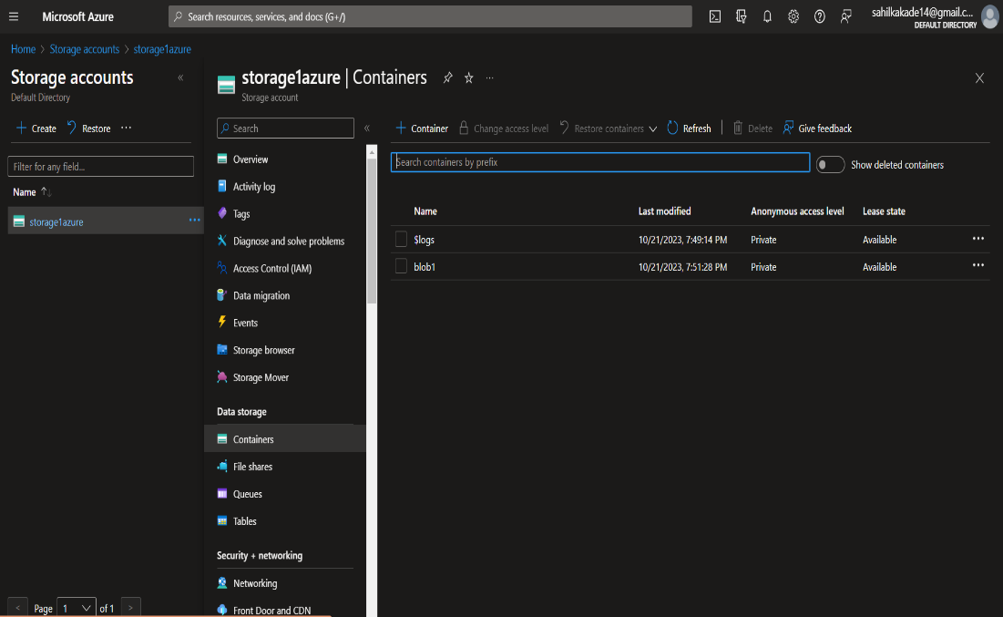

Now click on +container icon to add a conatiner

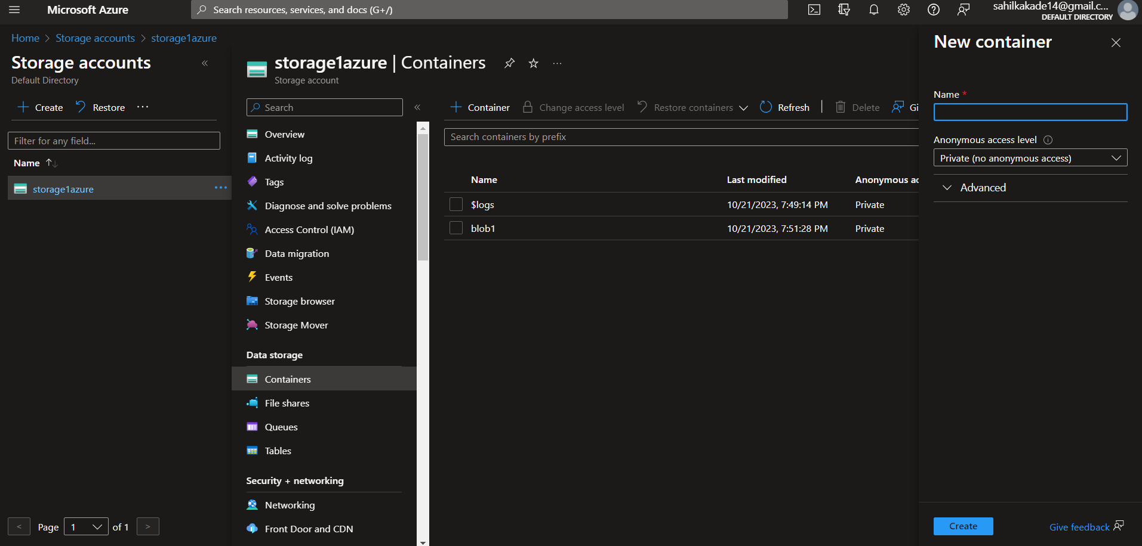

Give name and create one container.

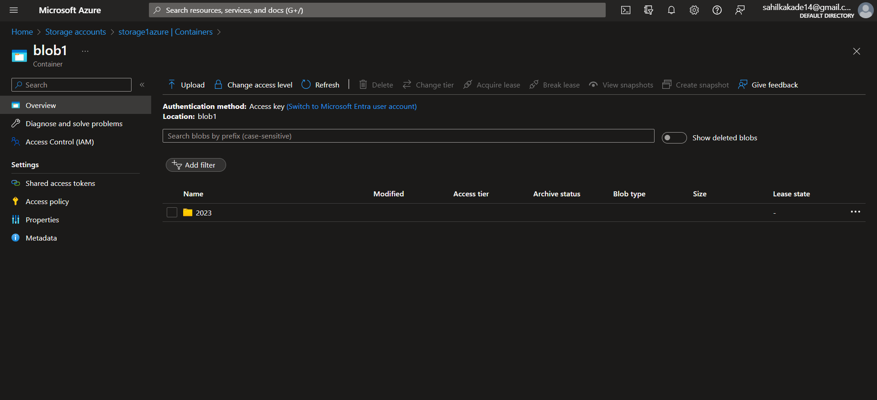

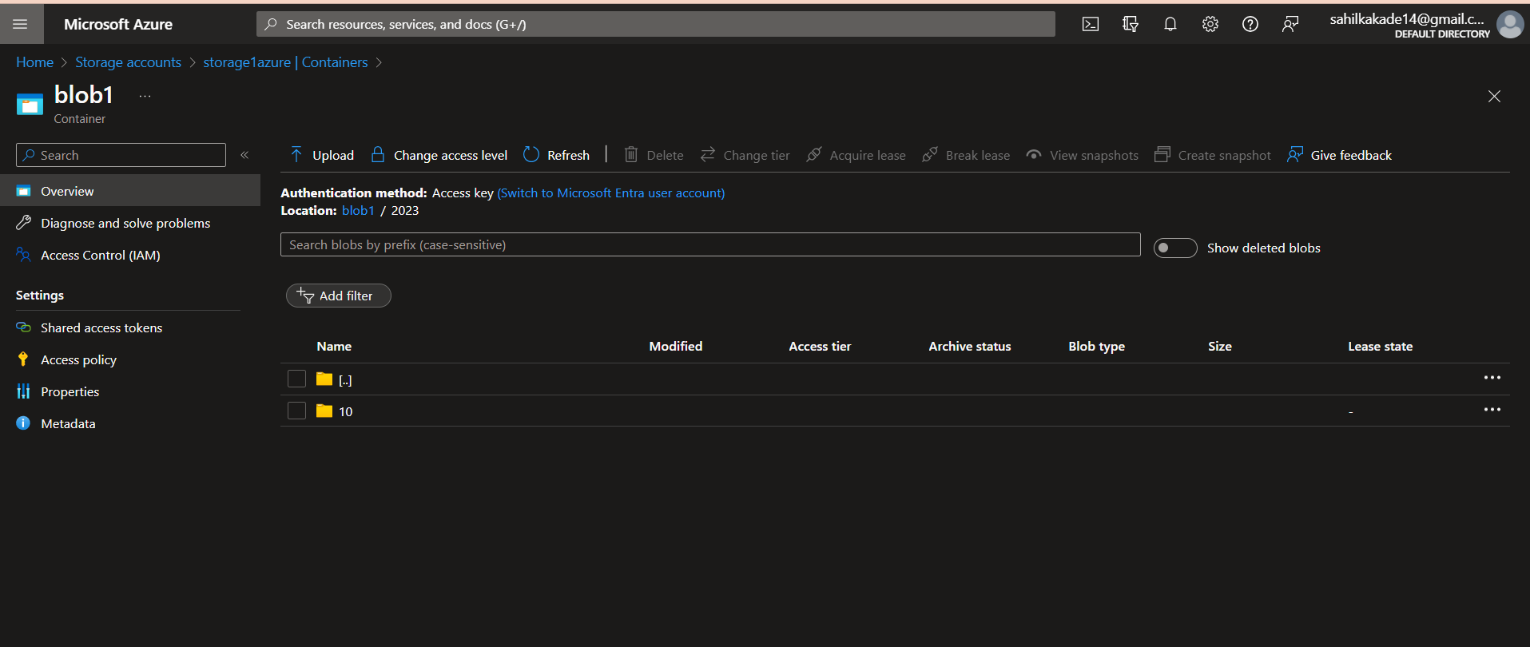

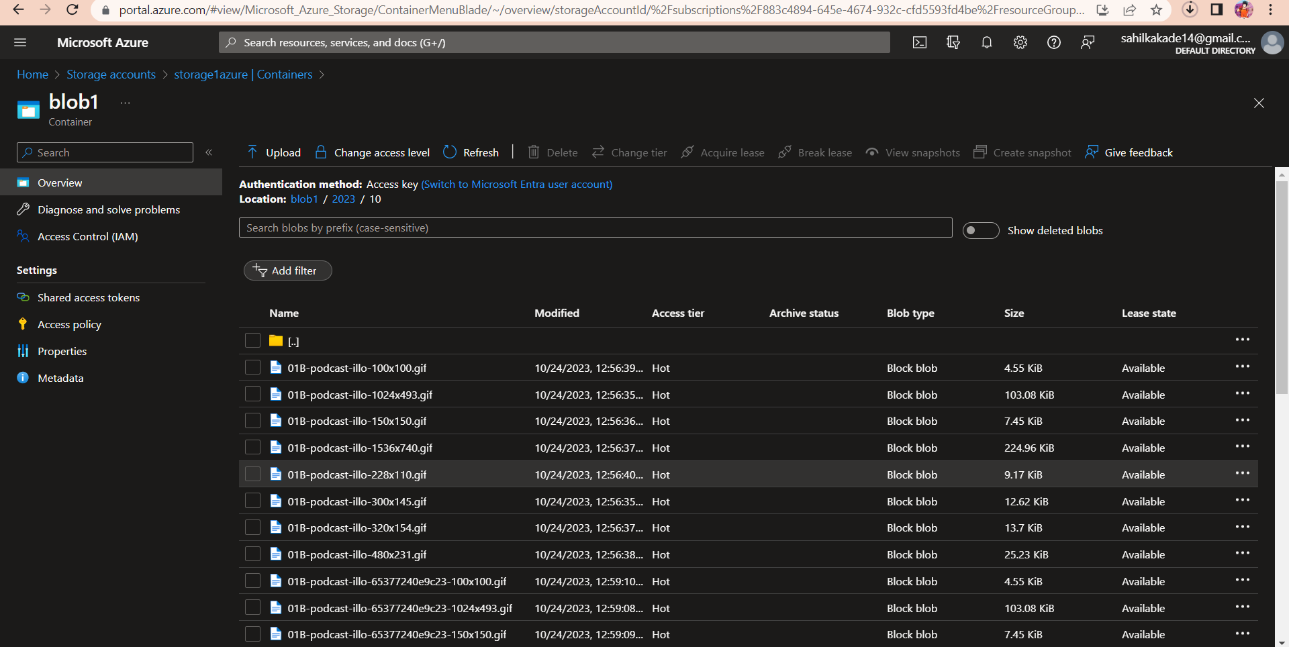

But to Create a backup in the storage account we have to connect that blob to our app service website

Step 6:-

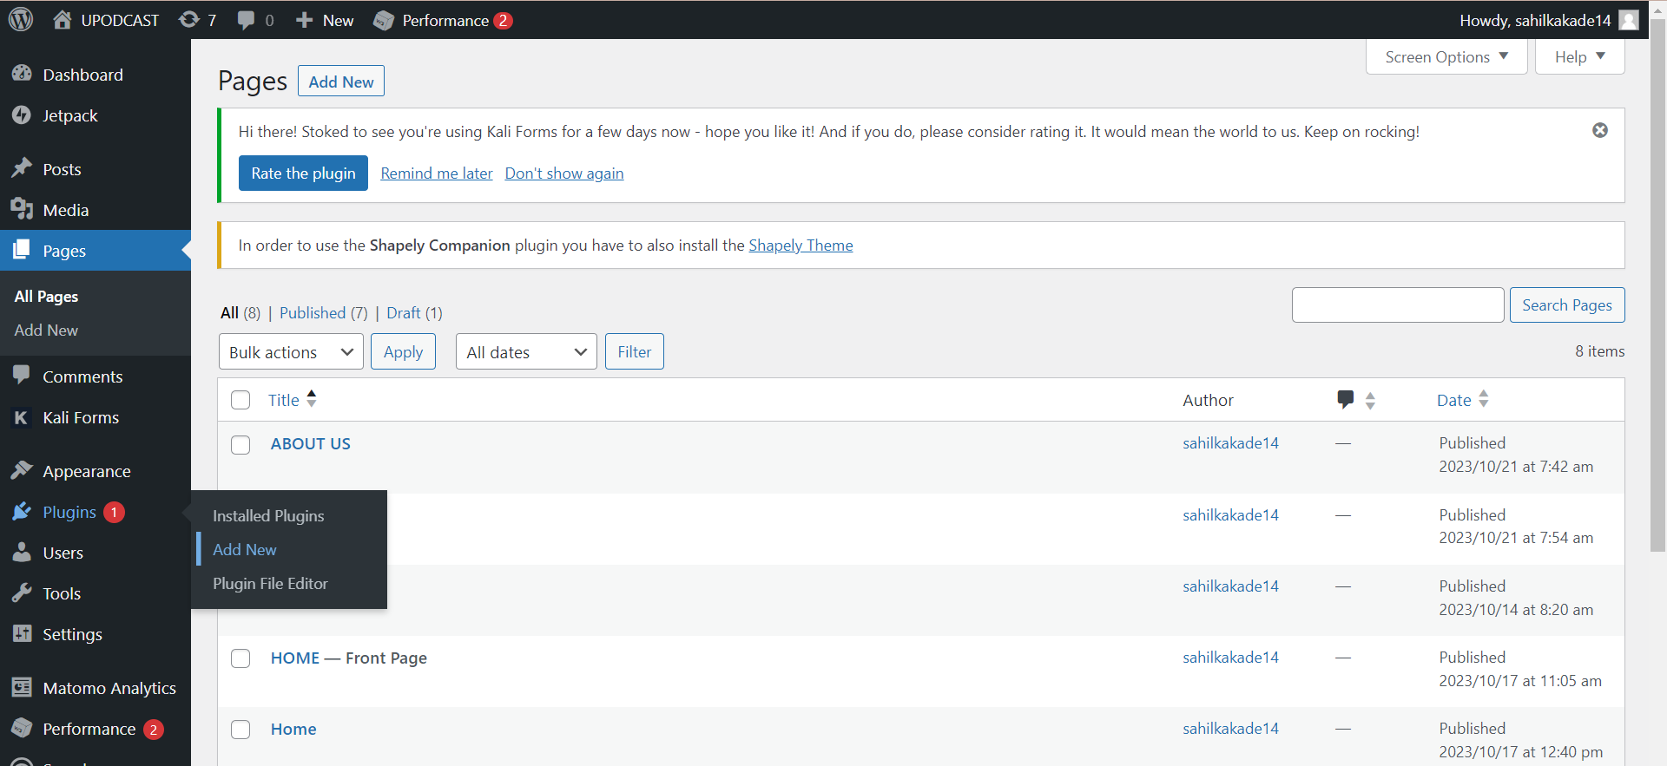

We have added a plugin to the website so it can connect to the azure storage account for the backup.

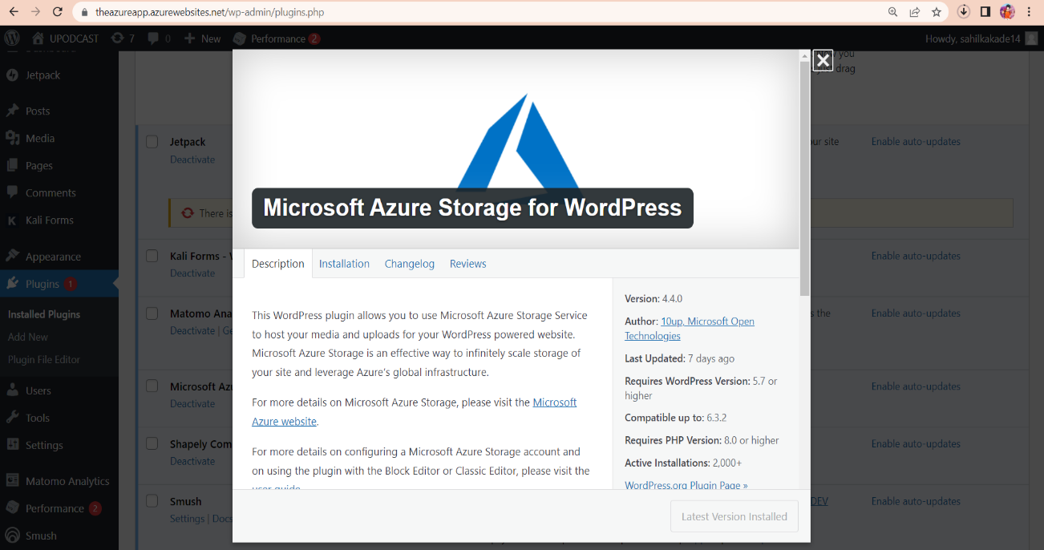

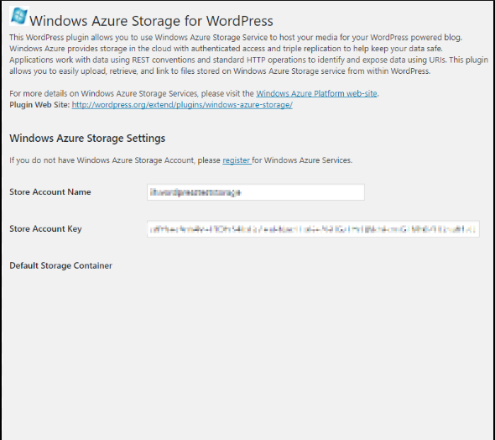

Activate the plugin and give storage account name and copy the account key from azure portal

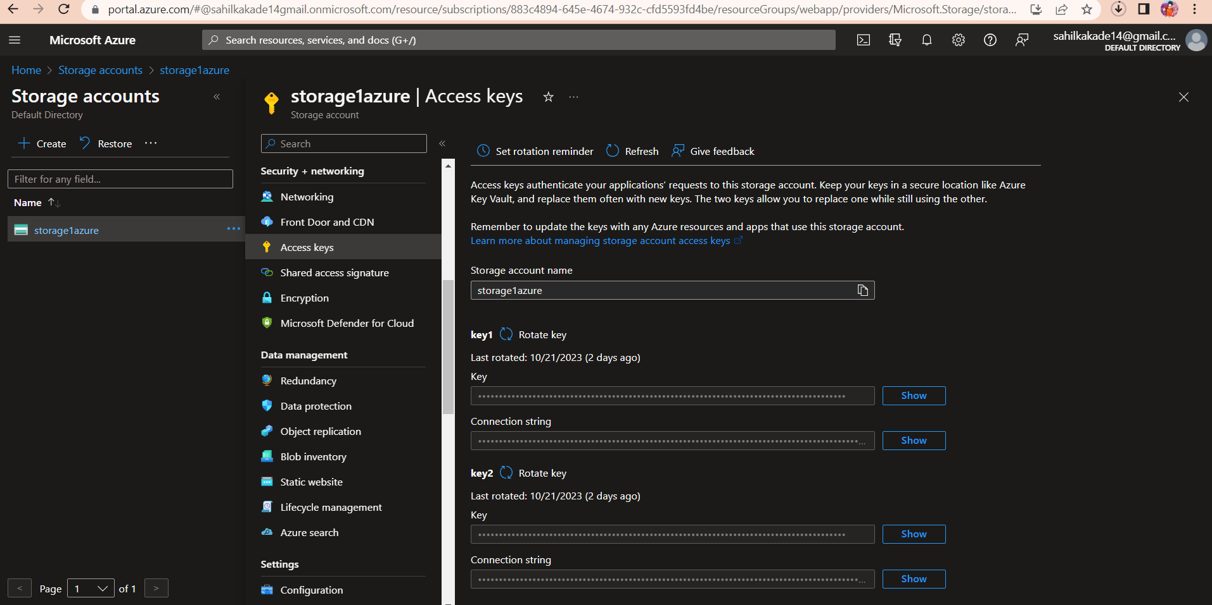

And click ok

Step 7:- Adding Application Insight Service to the Project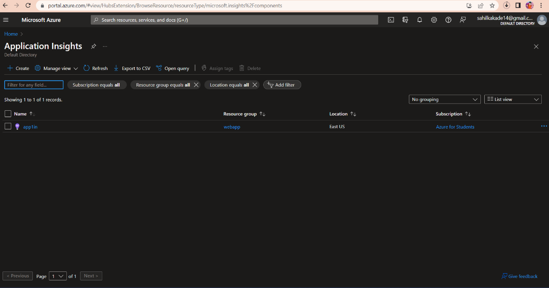

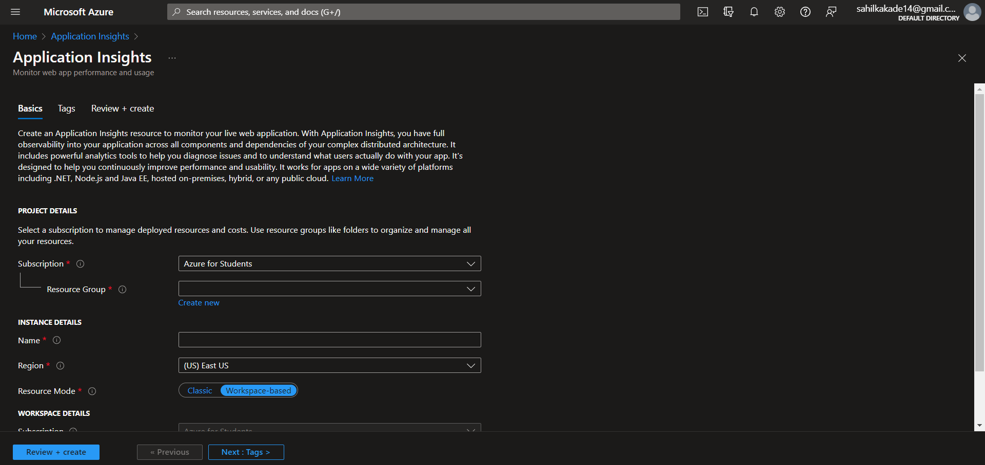

Click on create and enter the data according to user requirements select same resource group give name and region review + create

Now to connect the application insight to the website we have to also install a WordPress plugin that will connect the website to the azure application insights which will give us the data about our website.

I) go to the dashboard of the wordpress website and go to the plugins section

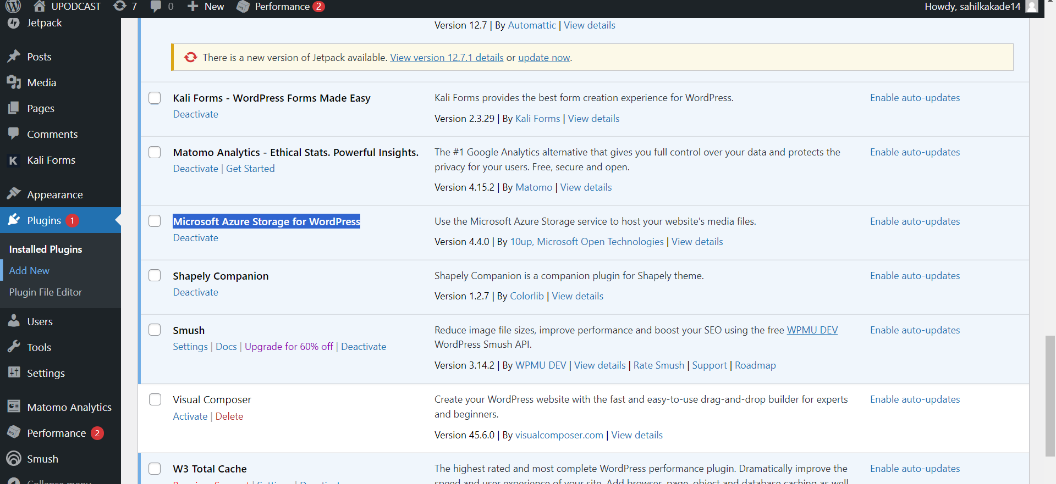

Click on add new plugin and select the

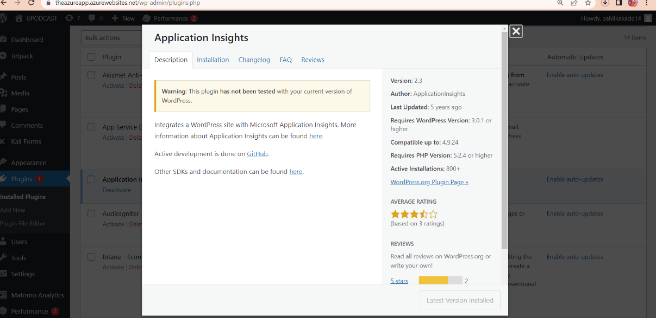

Install that above plugin and activate it.

II) and now copy the instrumention key from azure portal application insights

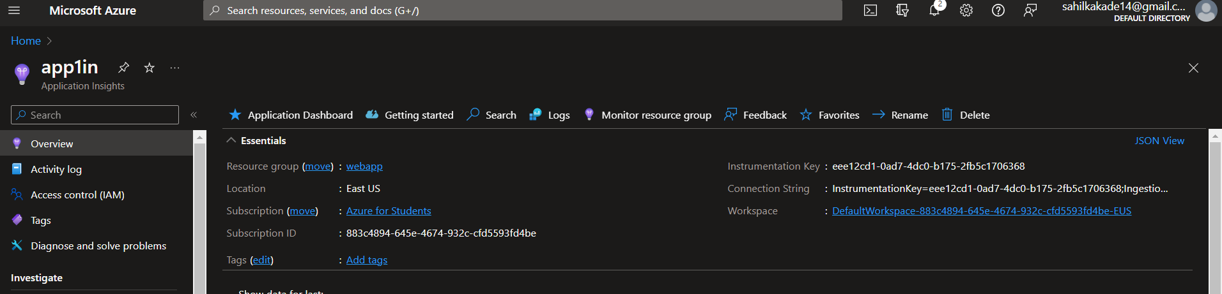

Copy the key from the portal to the plugin and paste it in the plugin of website and save the changes.

Now we are able to monitor the website insights .

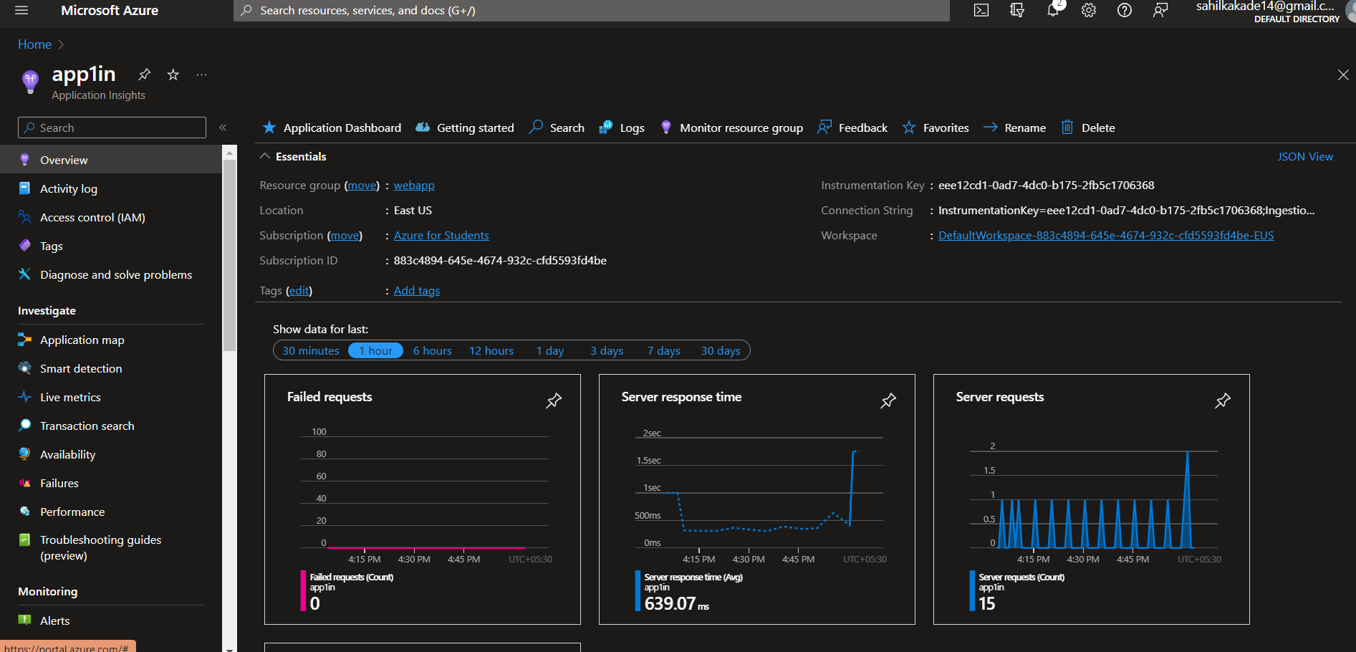

Overview Screenshots of our Website :

